Mini Amazon API Core
Outputs Demo Example:
Used Swagger To Test The API :
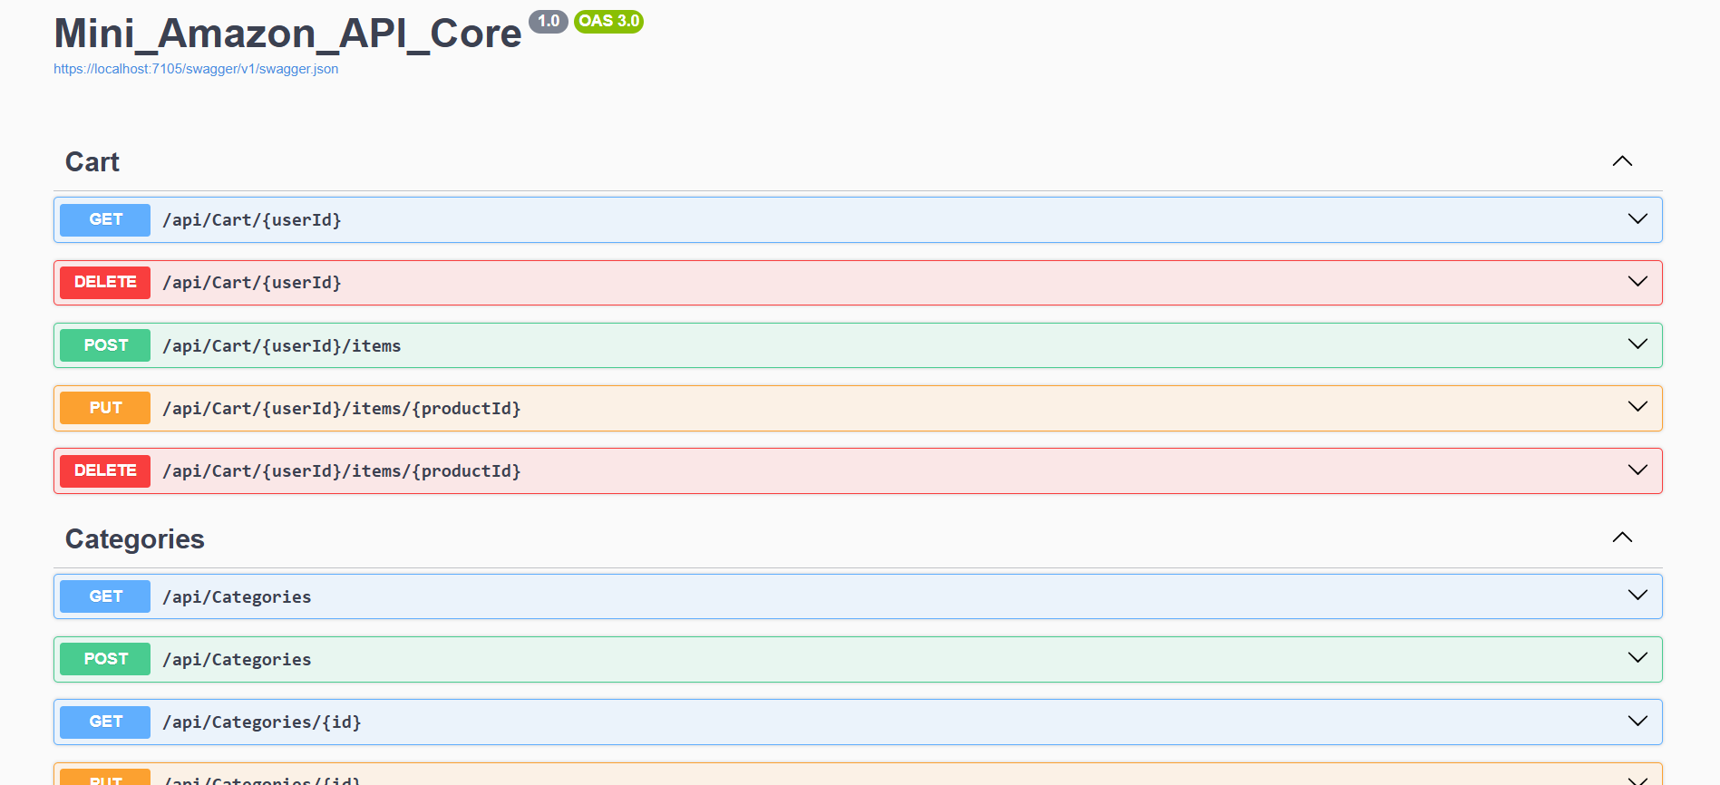
Created A user Named Omar Yasser Using Post :
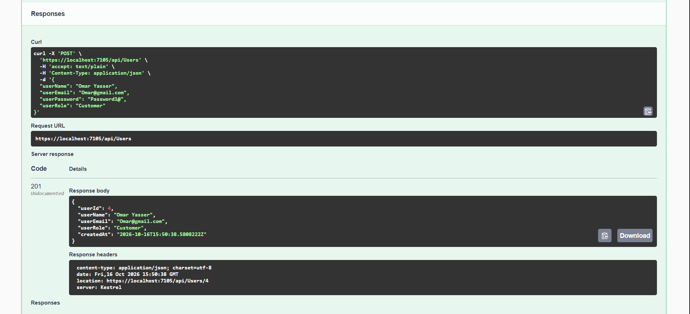
Used Get to Retrieve All Users In the DB:
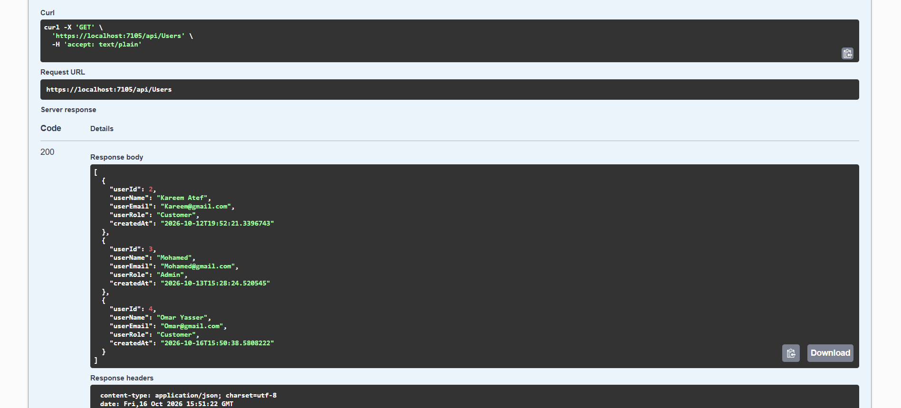
After Creating A product Named Samsung galaxy s26 related to the electronics Category Using Post I searched about it Using Get :
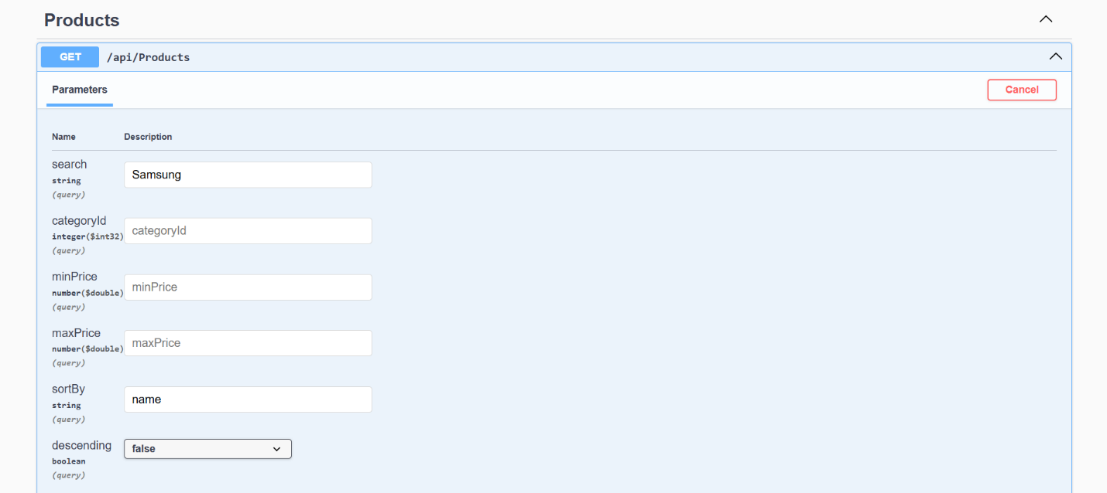

Output of products GET Search:
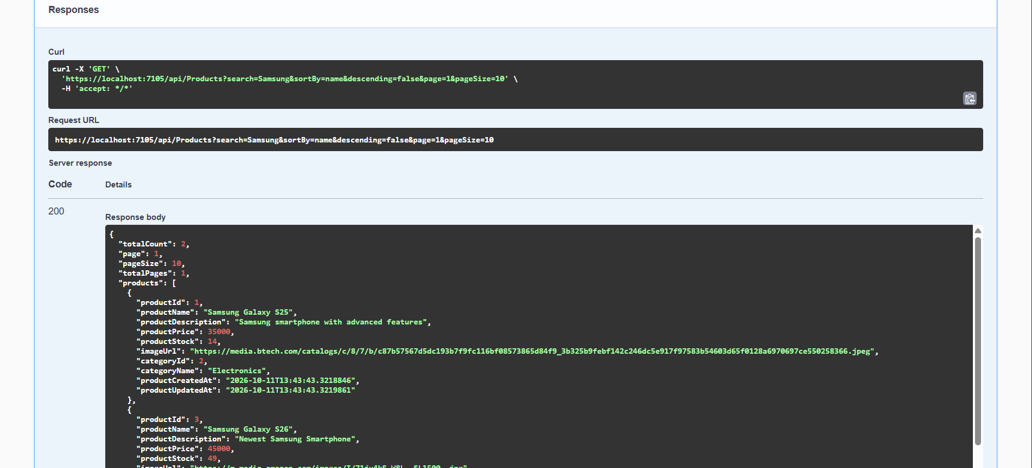
I added Two Products to Omar’s Cart Using Cart’s POST, Then I used GET to Retrieve Omar’s Cart :
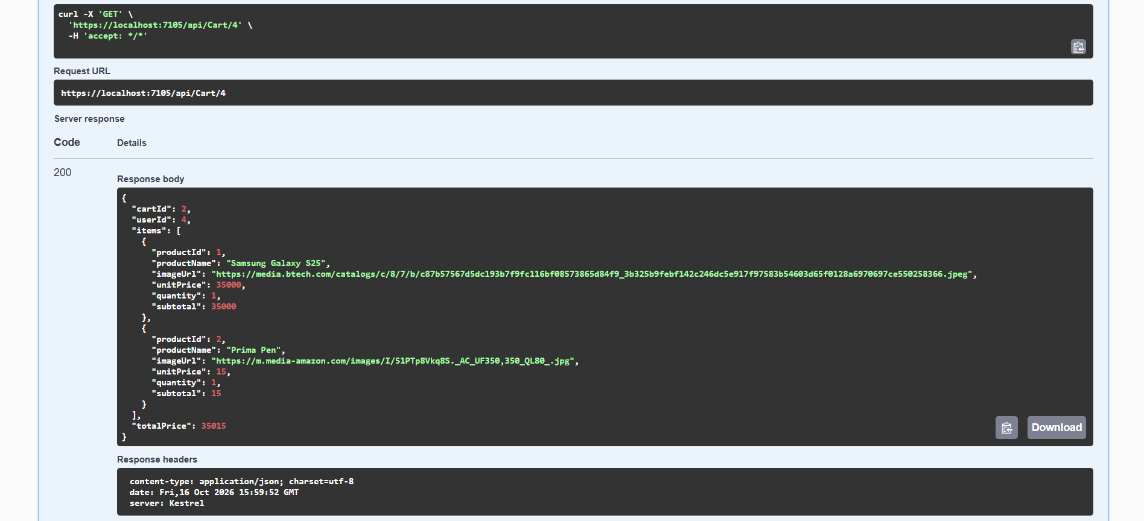
I created an order Using order’s POST After Entering in its headers the Omar’s UserId :
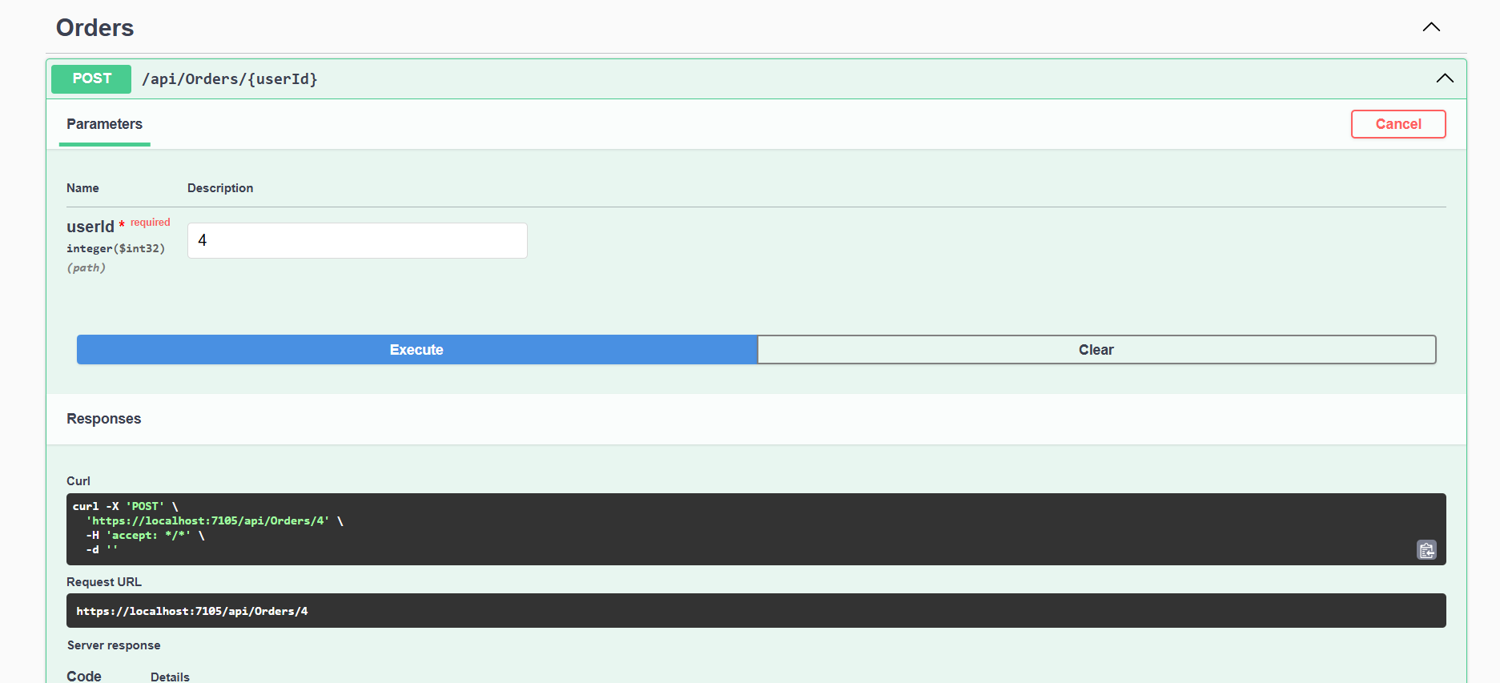
Omar’s Order Receipt :
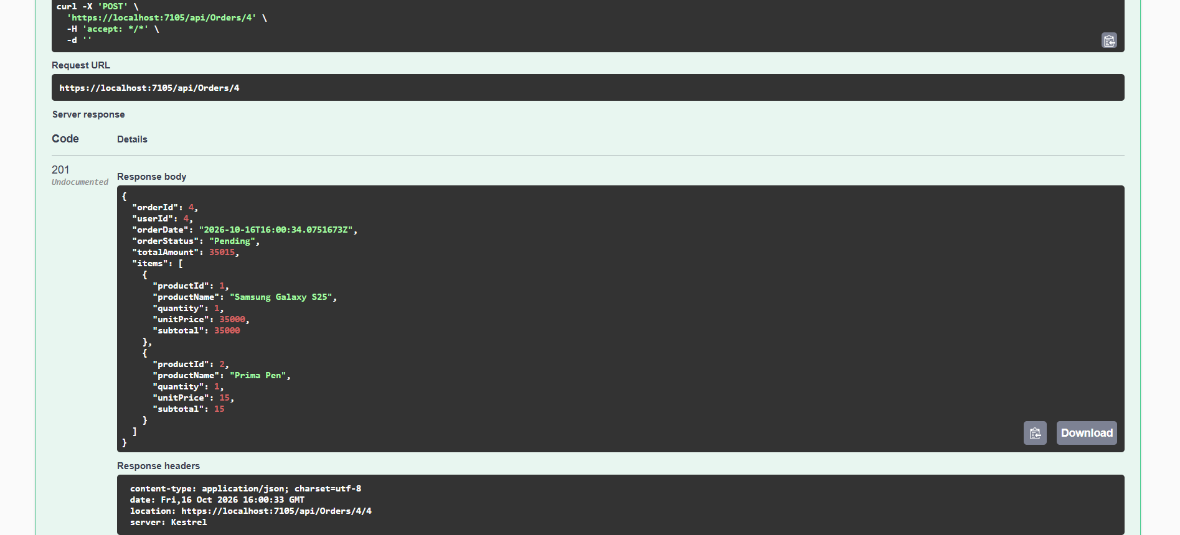

Notice That Omar’s Cart is cleared after Making His Order:
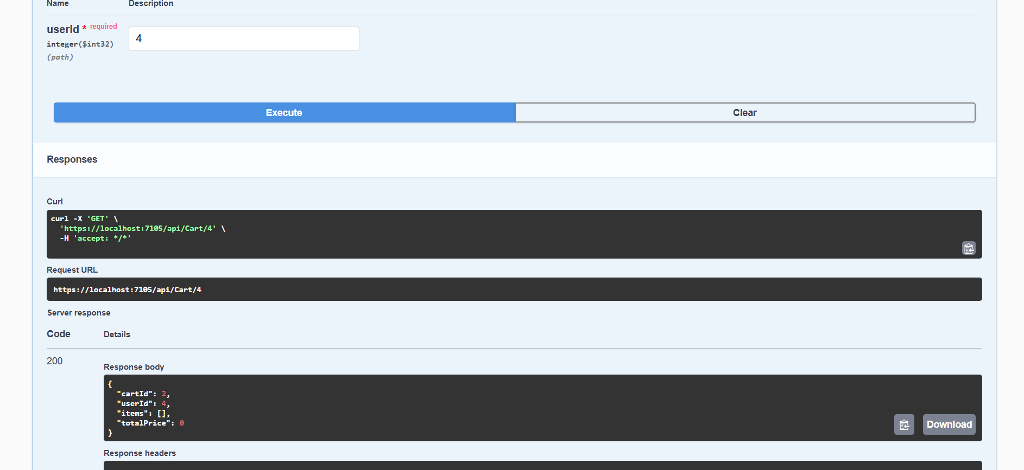
SQL Server ERD:
